**Compile & Run Metascan Online Uploader**

1. **Main features**
   1. Free of Metascan Online key setting (***Settings menu***)

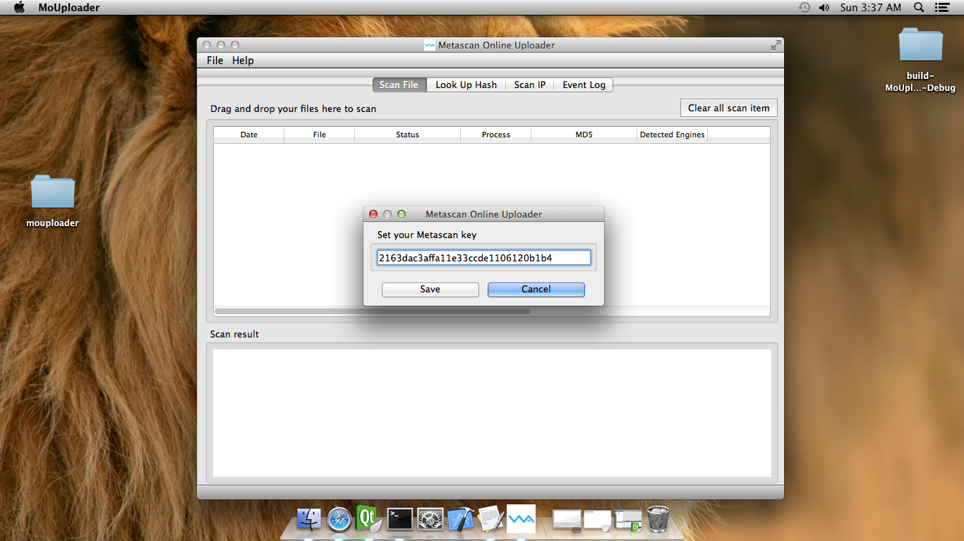

* 1. Scan file by using either open-file dialog or drag-drop multiples files

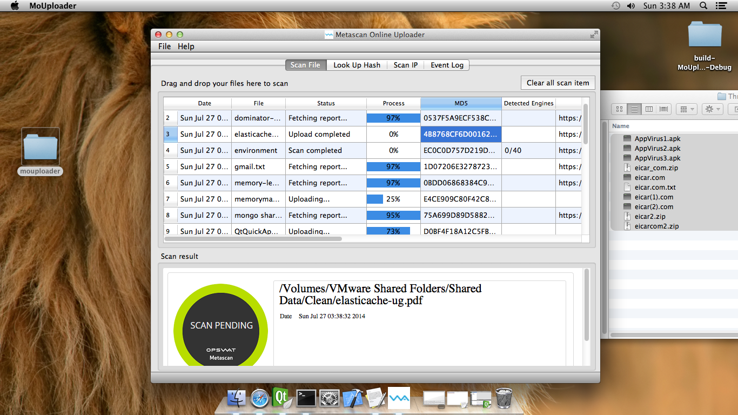

* 1. Show scan detail: You can search the hash on table scan

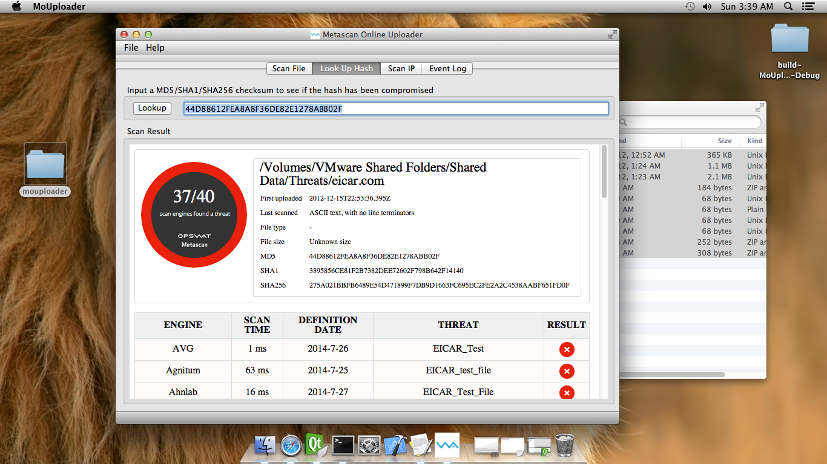

* 1. Lookup hash: You can input a hash and check it on Metascan Online server
  2. Scan IP address: You can input an IP Address and using Metascan Online API to scan
  3. Eventlog for saving scan history using SQL Lite
  4. The MoUploader app can work well on many platform such as: Windows, MAC, Linux

1. **Compile**
   1. For MAC: did test on MAC OS X 64 bit version 10.9, 10.8, 10.7
      1. Install XCODE
      2. Install Command Line Tool
      3. Install Qt SDK 5.3
      4. Set environment path for QT_HOME/bin: e.g.: ***/Users/test/Qt5.3.1/5.3/clang_64/bin***
      5. cd /source
      6. qmake
      7. make
   2. For Linux: did test on Ubuntu 14 32 bit
      1. Install Qt SDK 5.3
      2. Install gcc: apt-get install build-essential
      3. Install OpenGL: sudo apt-get install freeglut3 freeglut3-devs
      4. Set environment path for QT_HOME/bin: e.g.: ***/home/ble/Qt5.3.1/5.3/gcc/bin***
      5. cd /source
      6. qmake
      7. make
   3. For Windows: did test on Windows 7 64bit
      1. Install Qt SDK 5.3
      2. Set environment path for QT_HOME/bin: e.g.: ***C:\Qt\Qt5.3.1\5.3\mingw482_32\bin***
      3. Set environment path for QT_MINGW_HOME/bin: e.g.: ***C:\Qt\Qt5.3.1\Tools\mingw482_32\bin***
      4. cd /source
      5. qmake
      6. mingw32-make
2. **Demo**
   1. Please check on ***“Demo”*** folder
   2. Can test on MAC by run ***MoUploader.app*** (Just unzip and double click to execute)

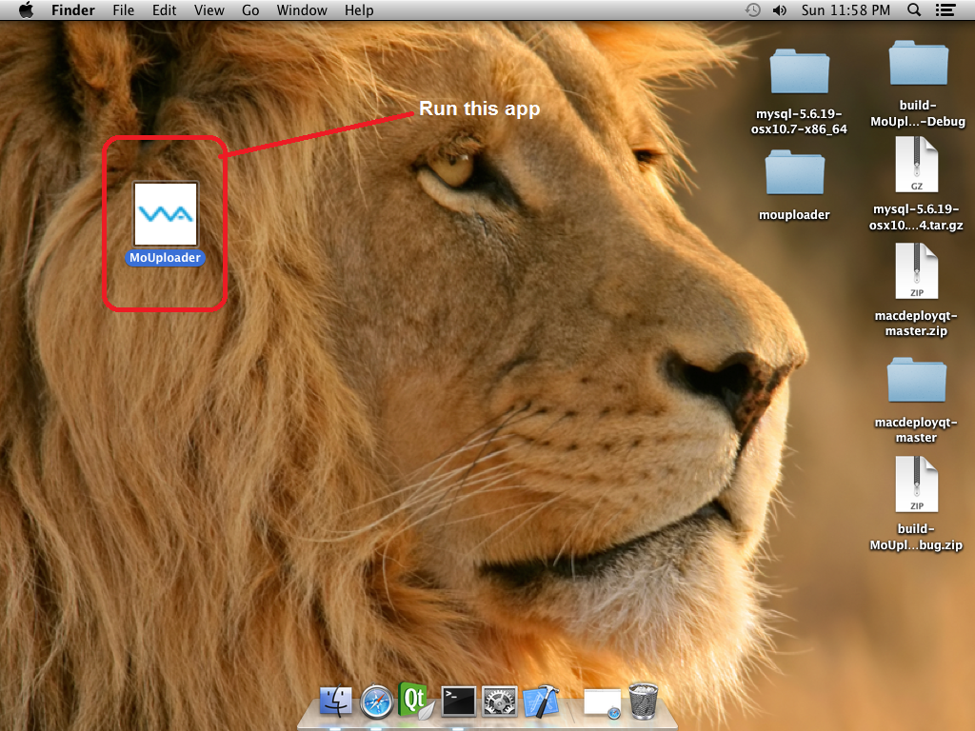

1. **MoKey**
   1. You can test by using this key: ***22b92a172002e8615dc0d1cfb93d261b***
2. **Install *Qt***
   1. Go to <http://qt-project.org/downloads>
   2. Click on green button “Show Download”
   3. Select the best fit installer (Should download the offline installer)
3. **The limitation**
   1. The UI is inconsistent between many platforms so that we need to check it for every platform before release.
   2. Maybe some bugs can appear on different platform.
4. **Deploy app**
   1. MAC:
      1. cd /source
      2. qmake
      3. make
      4. macdeployqt /MoUploader.app
      5. If there is an error message “Macdeployqt - ERROR: no file at “/opt/local/lib/mysql55/lib/libmysqlclient.18.dylib” we can resolve it by either steps:
         1. Install mysql (If not available) and create the soft link to libmysqlclient.18.dylib
         2. Or you Just need to copy “libmysqlclient.18.dylib” from the “demo” to the path /opt/local/lib/mysql55/lib/ (create directory if it does not exist)
      6. Macdeployqt /MoUploader.app
   2. Windows: can refer to http://qt-project.org/doc/qt-4.8/deployment-windows.html
   3. Linux: can refer to http://qt-project.org/doc/qt-5/linux-deployment.html